**Leader Overview**

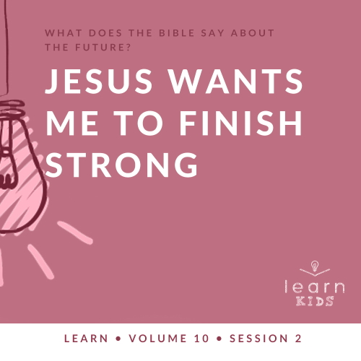

**Volume Overview**

**What does the Bible say about the future?**

*It’s easy to see that our society is obsessed with the future. But what does the Bible say about the future? While it was written thousands of years ago and much of its contents has already taken place, we do get a glimpse of the future in the Bible. We know there is life beyond this life. We know the brokenness and pain in this world will not last forever. We know God will make all things new, and He will right every wrong. For Christians, the future is something we can look forward to.*

**Session Overview**

**Jesus Wants Me to Finish Strong**

*We know Jesus is coming back, but we don’t know when. The Parable of the Ten Bridesmaids reminds us that we need to be ready for Him to come back at any time. Kids will find out why it’s important to run the race of life according to God’s plan and finish strong.*

**Bible Lesson**

Parable of the Ten Bridesmaids

[Matthew 25:1–13](https://ref.ly/logosref/Bible.Mt25.1-13)

**Faith Fact**

Jesus wants me to be ready.

**Faith Verse**

[1 Corinthians 2:9](https://ref.ly/logosref/Bible.1Co2.9) (NLT)

“No eye has seen, no ear has heard, and no mind has imagined what God has prepared for those who love him.”

**Preparing for the Session**

**Leader Preparation Time: 20–25 Minutes**

|  |
| --- |
| ***You Will Need***  ***Large Group***   * *Bible* * *Worship songs (Song suggestions: “Revelation Song” by Gateway Worship; “Ready or Not” by Hillsong UNITED; “Alive” by Hillsong Young & Free; “Zeal” Lyric Video by The Belonging Co)* * *For groups not using a phone or tablet only, add:*   *• Projector or TV*  *• Laptop*  *•* ***Faith Fact Slide***  *•* ***Faith Verse Video*** *or* ***Slide***  *•* ***Bible Lesson Video***  *•* ***Teaching Point Slides 1–3***   * *Running shoes* * *Towel* * *Medal*   ***Small Group***   * *Small pieces of paper, at least one per kid* * *Pen* * *Small container* * *Smartphone, stopwatch, or watch to use as timer* * *Bibles for kids in your group to share* * *Cups, two per group* * ***Small Group Faith Verse Review Page****, two sets per group* * *Scissors* * ***Small Group Activity Page****, one per kid* * ***Small Group Activity Page Answer Page****, if needed* * *Pencils, one per kid*   *To access session content and videos from a computer, visit:* [*BibleEngagementProject.com/downloads*](https://bibleengagementproject.com/downloads) |
| ***Getting Ready***  ***Large Group***   * *Download videos and slides if needed.* * *Select worship song(s) and have them ready to play.* * *Read the Bible Lesson Scripture to prepare for teaching time.*   ***Small Group***   * *Write different topics on each small piece of paper, fold the pieces of paper, and place them in the small container. Make a set of topics for each small group.*   *Topic suggestions: Pet, sibling, hobby, something you’re good at, sports, TV, family, best friend, church, God, the Bible*   * *Print two copies of the* ***Small Group Faith Verse Review Page*** *per group.* * *Place one set of verse words in each cup.* * *Print copies of the* ***Small Group Activity Page****, one per kid.* * *Print a copy of the* ***Small Group Activity Page Answer Page*** *if needed.*   *First time leading Learn for Kids? Check out the* [*Facilitator Guide*](https://0b769b0ed3569ef9d18b-f88d8272f61086866d50d048b43ef630.ssl.cf2.rackcdn.com/sites/biblengagementproject/Listen_Facilitator_Guide.pdf)*.* |

**Large Group**

**30 Minutes**

*See what’s needed at the beginning of the session.*

**Introduction**

It’s great to see all of you here today! We’re talking about what the Bible has to say about the future. Are you interested in the future? (*Group response)* Most people are curious about what the future holds.

Last time, we learned Jesus is coming back, but we don’t know when. What does that mean for us? It means we need to be ready for Him to return at any time. When we’re following Jesus, our job is to live for Him every single day.

**Faith Fact**

The Bible tells us that Jesus wants us to be ready for His return. Our Faith Fact today is: **Jesus wants me to be ready.**

• *Show the* ***Faith Fact Slide.***



Let’s say the Faith Fact a couple of more times together. While we say it, we’re going to run in place as fast as we can. Let’s give that a try! **Jesus wants me to be ready.** One more time: **Jesus wants me to be ready.**

**Game**

**Time’s Up!**

Jesus wants us to be ready for Him to come back at any time. First of all, we need to be following Jesus. Then, our job is living for Jesus every day. Following Jesus our whole life is like running a race that takes a lot of endurance. *Endurance* means we keep going no matter what. It can be easy to think we have all the time in the world to do the right thing and spend time with Jesus. But the truth is, we have no idea when our time on earth will end.

In today’s game, we’ll see if you can be ready for anything—and we’ll practice endurance! When I tell you an action or exercise, you’ll keep doing it until I say stop. If you give up, you’re out of the game. Let’s go!

• *Name different actions and exercises for the kids to do: running/marching in place, waving your arms, staring without blinking, being totally silent, jumping jacks, hopping, crawling, standing on one foot, freezing in place, etc.*

• *Vary the length of time you expect kids to keep doing the action/exercise to keep them guessing.*

• *Optional: Let kids take turns naming actions.*

• *As kids stop or give up, they’re out of the game.*

• *Keep playing until you run out of time or the kids are worn out.*

Is anyone totally worn out? *(Group response)* I am! You have some great endurance. Endurance is one thing we need to live for Jesus and be ready when He comes back. It wasn’t easy to do all those exercises, and it’s not always easy to keep doing the right thing while we’re waiting for Jesus to come back. I’m glad Jesus is willing to help us.

**Worship**

Don’t sit down just yet! Let’s give the same level of energy in our worship that we just gave during game time. We’re going to sing and worship God now.

• *Lead the kids in singing one or two praise songs. See suggestions at the beginning of the session.*

**Bible Lesson**

I have good news! It’s time to sit down and learn something new about the future from God’s Word. Last time, we heard Jesus’ parable from [Matthew 24](https://ref.ly/logosref/Bible.Mt24) about a master and his servants. Today, we’re picking up where we left off with another parable Jesus taught. This one is in [Matthew 25](https://ref.ly/logosref/Bible.Mt25). Before we read it together, let’s invite Jesus into our Bible time. Let’s pray.

**Prayer**

|  |
| --- |
| *Dear Jesus, please help us to learn how to be ready for Your return. We want to be prepared to finish strong. Amen.* |

**Video Intro**

Before we hear the Bible story, let’s watch this video.

• *Play* ***Bible Lesson Video.***

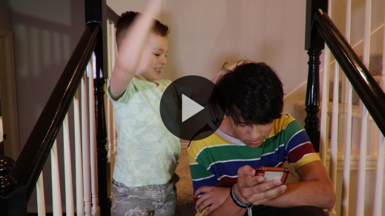

**Bible Story**

**Parable of the Ten Bridesmaids**

That video was a great way to set up our Bible story today! In [Matthew 24](https://ref.ly/logosref/Bible.Mt24) and [25](https://ref.ly/logosref/Bible.Mt25), Jesus told a few parables about His return. Why do you think Jesus taught more than one parable about the same thing? (*Allow responses.)* Maybe Jesus knew different examples would make sense to different people. It is so important to Jesus that His people are ready for His return. It’s time to open your Bible or Bible app and go to [Matthew 25:1–13](https://ref.ly/logosref/Bible.Mt25.1-13).

• *Read the passage aloud to the group.*

• *In order to keep Large Group time moving along, we don’t recommend having the kids read.*

• *Optional: Remind the kids to mark this place with their Bible Bookmark, so they can read it on their own at home.*

**Teaching Time**

|  |
| --- |
| ***You Will Need***   * *Running shoes* * *Towel* * *Medal*   *No prep needed for this activity.* |

Last time, Jesus used the example of a master and servants to explain His return. This time, He used the example of a wedding. Raise your hand if you’ve been to a wedding before. *(Group response)* Keep your hand up if you were the bride or the groom. Just kidding! The *bride* is the woman getting married, and the *groom* is the man getting married. You’re too young to get married! Now, raise your hand again if you’ve been in a wedding. *(Group response)*

In Jesus’ parable, there were ten bridesmaids who were waiting to meet the groom. *Bridesmaids* are women in a wedding who help the bride. They’re usually her friends or family members. These ten bridesmaids in Jesus’ parable didn’t know when the wedding was going to start, and they needed to be ready. But guess what! They fell asleep while they were waiting. When the groom came for the wedding, how many of the bridesmaids were ready? *(Group response)* Right! Only five of them had enough oil for their lamp. The other five weren’t ready, and they missed out on the marriage feast.

Remember, a *parable* is a story with a special meaning that teaches us something. Usually, people in a parable represent, or stand in for, someone else. In this parable, who do the groom, the wise bridesmaids, and the foolish bridesmaids represent? (*Allow responses.)* Jesus is the groom. The wise bridesmaids are those who were prepared for Jesus to come back. And the foolish bridesmaids are those who were not ready. Jesus is telling us not to be caught unprepared when He comes back.

Remember our Faith Fact? **Jesus wants me to be ready.** Say it with me. **Jesus wants me to be ready.** Jesus wants us to be like the five wise bridesmaids who were prepared for the groom’s return at any time. Here are a few things we can learn from Jesus’ parable and apply to our life.

**1. Everyone can finish strong.**

• *Show the* ***Teaching Point 1 Slide.***

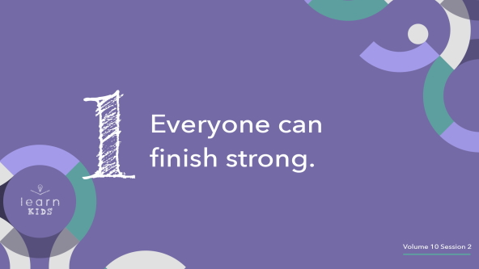

Jesus has given all of us the same opportunity to stay faithful to Him until He comes back. It’s like we’re each running our own race of life. (*Hold up the running shoes or put them on.)* When runners are ready to start a race, they all line up together. And they’re running toward the same goal: the finish line.

In life, we’re all running toward the same goal as well. But unlike a normal race, there isn’t one winner and a bunch of losers. We all can make it across the finish line and spend forever with Jesus. That’s the prize we’re running for, and it’s worth keeping up the pace!

**2. Everyone needs endurance to finish strong.**

• *Show the* ***Teaching Point 2 Slide.***

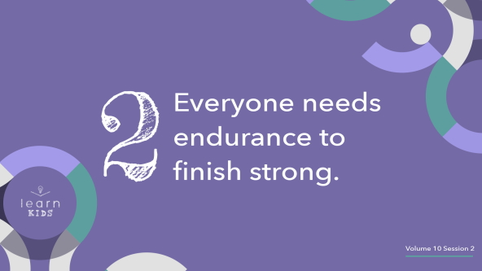

It’s not easy to finish strong in this life. Remember, in Jesus’ parable only half of the bridesmaids finished strong. Do you think there are times when a runner wants to quit running a race and walk off the track? *(Group response)* Of course.

• *Begin running and then slow down, wiping “sweat” off your face with a towel while you talk.*

Continuing to run the race means the runners might get tired, sweaty, or even go through some pain before they finish. They might get distracted by other runners and lose focus on the goal. But even if they fall down, they must get up and keep running to finish the race.

Lots of things might distract us or confuse us while we’re running. Maybe we’re tempted to sin. Maybe we hang out with friends who want us to do the wrong things. Or maybe we spend too much time doing things that aren’t important. To finish strong, we have to be determined and make it through lots of challenges. The bridesmaids who finished strong were ready to wait a long time. They made sure they had everything they needed to make it to the end. It won’t always be easy to keep following Jesus, but let’s focus on the finish line. Let’s keep going!

**3. Everyone must choose to finish strong.**

• *Show the* ***Teaching Point 3 Slide.***

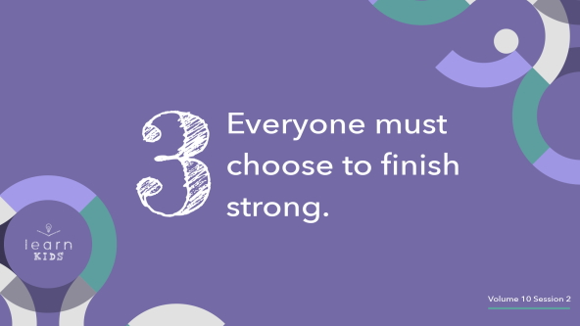

Jesus wants us to follow Him and stay faithful until the end. But we all have to decide that for ourself. Five bridesmaids chose to prepare and be ready. And five chose not to. Who do you want to be like? *(Group response)*

Think of it this way. Imagine a runner finishes a race, wins a medal *(hold up the medal),* and then just hands it to a random person. Does that mean the person who ended up with the medal finished the race? *(Group response)* No! Handing someone a medal doesn’t mean they ran the race.

It’s the same in life, too. Your parents can’t make the decision for you to believe in and follow Jesus. And Jesus won’t force you to love Him and spend time with Him. You have to decide that on your own. And then you need to stick to that decision every day.

Jesus will help you make it through every challenge if you ask Him for help, but He won’t run the race for you. Only you can decide to believe in and follow Jesus. Only you can decide to stay faithful to Him. Only you can make sure you’re ready when He comes back. When you make that choice every day—like the five wise bridesmaids—you will finish strong!

**Prayer and Response**

*Consider playing a worship song softly in the background while kids pray.*

Are you ready to decide to follow Jesus? Or maybe you want to commit to finishing strong. If you’re serious about making that choice today, I want you to stand up and come to the front. We’re going to lift our hands together and ask Jesus to help us follow Him and finish strong.

• *Pause while kids come to the front.*

• *Pray for them individually if you have time.*

**Prayer**

• *Optional: Have the kids repeat phrases of the prayer after you.*

|  |
| --- |
| Dear Jesus, I am deciding right now to follow You for my whole life. Help me to stay close to You and finish my race strong. Amen. |

**Faith Verse**

Our Faith Verse reminds us God’s ways are so much better than ours. That’s why He knows all the details of the future, and we only know bits and pieces. Let’s say our Faith Verse and do the actions together.

• *Play* ***Faith Verse Video.***

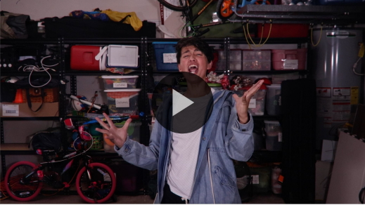

[1 Corinthians 2:9](https://ref.ly/logosref/Bible.1Co2.9) (NLT)

“No eye has seen, no ear has heard, and no mind has imagined what God has prepared for those who love him.”

I can’t wait to find out what God has prepared for us after we finish strong!

**Faith Fact**

Before we go to our small groups, let’s go over our Faith Fact one more time.

• *Show the* ***Faith Fact Slide.***



Say it with me. **Jesus wants me to be ready.** I hope you’re ready to learn even more about the future Jesus has planned for us!

• *Dismiss kids to Small Group time or to go home if your group time ends here.*

**Small Group**

**30 Minutes**

*This section can be done in conjunction with the large group or on its own if you do small groups with your kids. During Small Group time, the goal is to connect the kids with the Word of God and to each other. All activities are led by the small group leader.*

**Group Connection**

**Beat the Clock**

|  |
| --- |
| ***You Will Need***   * *Small pieces of paper, at least one per kid* * *Pen* * *Small container* * *Smartphone, stopwatch, or watch to use as timer*   ***Getting Ready***   * *Write different topics on each small piece of paper, fold the pieces of paper, and place them in the small container. Make a set of topics for each small group.*   *Topic suggestions: Pet, sibling, hobby, something you’re good at, sports, TV, family, best*  *friend, church, God, the Bible* |
|  |

We need to be ready for Jesus to return at any time. Remember, the five wise bridesmaids in Jesus’ parable were ready for Him to come back, and the five foolish bridesmaids were not. They missed the wedding! We want to be like the wise bridesmaids and be ready all the time—no matter when Jesus comes back.

How many of you like sharing stories about your life? (*Group response)* You’ll need to tell really fast stories in today’s game. When it’s your turn, I’ll give you a topic. You’ll have twenty seconds to tell a story about that topic. Do you think you can beat the clock? *(Group response)* Who wants to go first?

• *Give each kid a topic when it’s their turn, and start the 20-second timer.*

• *Keep playing until everyone has had a chance to share a story and beat the clock.*

Those were some quick stories! It was fun to learn a little more about each one of you. Way to be ready for anything!

**Learn about It**

|  |
| --- |
| ***You Will Need***   * *Bibles for kids in your group to share*   *No prep needed for this activity.* |

**Scripture Search:** [2 Timothy 4:7–8](https://ref.ly/logosref/Bible.2Ti4.7-8); [Philippians 3:13–14](https://ref.ly/logosref/Bible.Php3.13-14); [2 Timothy 4:1–5](https://ref.ly/logosref/Bible.2Ti4.1-5)

Let’s learn more about what the Bible says about being ready for Jesus to come back. As we find and read these verses, let’s ask ourself this question: What does this Scripture mean for our life today and the future?

• *Give each kid a Bible and search for one or more of the Scriptures as a group together (as time allows). When everyone has found the Scripture, have one of the kids read it. Then answer the question about it: What does this Scripture mean for our life today and the future?*

• *Pair kids who need additional help with older kids or start simple and look up the session’s Bible story Scripture:* [*Matthew 25:1–13*](https://ref.ly/logosref/Bible.Mt25.1-13)*. Kids will get better at finding Scriptures the more they practice.*

• *Optional: Make this a competition to see who can find the Scripture first.*

**Bible Reading Tip**

When you’re reading your Bible, try to find ways to apply it to your own life. Ask God to show you what He wants you to learn. Put yourself in the main character’s place in whatever story you’re reading. Imagine what they might have been thinking or feeling. Think of ways they could have handled things better. Use your imagination! It’s okay to have fun and be creative while you’re reading your Bible.

**Challenge**

Your challenge this week is to read the Parable of the Ten Bridesmaids in [Matthew 25:1–13](https://ref.ly/logosref/Bible.Mt25.1-13) on your own. Try to imagine how the five foolish bridesmaids felt. Learn from their choices, and make sure you’re ready for Jesus to come back.

**Faith Fact**

Our Faith Fact reminds us how important it is to be ready. Say it with me again. **Jesus wants me to be ready.**

**Group Discussion**

*Feel free to use all or just a few questions as a jumping-off place for good discussion. Questions marked with * are designed for more conversation. Adjust the questions based on the age or maturity of your group. Typically, older kids will be able to dive a little deeper than younger ones.*

**Questions**

• *If small group activities are not immediately following large group time, you may want to read the Bible story passage before this discussion.*

How many bridesmaids were there in Jesus’ parable?

What did the foolish bridesmaids forget to bring with them?

* Do you feel more like the wise bridesmaids or the foolish bridesmaids? Why?

How can you make sure you’re ready for Jesus to come back?

* Is it easy or hard to stay faithful to following Jesus? Why?

* Think about life like it’s a race. What are some challenges you might face?

Who do you ask for help when you are tempted to do something wrong?

What should a person do if they’re tempted to quit following Jesus?

What is something you can do to keep running the race and finish strong?

**Prayer Requests**

*Finish group discussion by sharing prayer requests and praise reports. Keep track of your small group’s prayer requests and review them each time you meet.*

**Prayer**

*Have kids pray for each other’s prayer requests.*

**Faith Verse Review**

|  |
| --- |
| ***You Will Need***   * *Cups, two per group* * ***Small Group Faith Verse Review Page****, two sets per group* * *Scissors*   ***Getting Ready***   * *Print and cut apart* ***Small Group Faith Verse Review Page****, two sets per group.* * *Place one set of verse words in each cup.* |

Our Faith Verse is [1 Corinthians 2:9](https://ref.ly/logosref/Bible.1Co2.9). It tells us something amazing! God is making preparations for us to spend forever with Him. Let’s make sure we’re doing our part to get ready for that too! Let’s say the verse together.

• *Show* ***Faith Verse Video.***



[1 Corinthians 2:9](https://ref.ly/logosref/Bible.1Co2.9) (NLT)

“No eye has seen, no ear has heard, and no mind has imagined what God has prepared for those who love him.”

**Faith Verse Fun**

**Relay Scramble**

Who thinks they can say the Faith Verse all by themselves? *(Allow responses.)* Who can say it superfast? *(Allow kids to try saying it quickly.)* Whew, that was fast! Now let’s see just how fast you can put the Faith Verse in order.

We’ll divide into two teams for this game. Each person on the team will race against a person on the other team. When it’s your turn, you’ll run to a cup filled with all the words in our Faith Verse. Unscramble the words as fast as you can. Whoever puts the verse together first wins a point for their team.

• *Create two evenly sized teams.*

• *Place the cup for each team across the playing area*.

• *Allow kids to compete in pairs if you have a large group or kids who don’t know the verse yet.*

• *Members of the team should cheer for the kid from their team sorting the verse.*

• *After each runner unscrambles the words, mix the words up and put them back in the cup*.

• *Keep score for the teams, and declare the winner after everyone has raced*.

Your teams worked so fast! Great job learning our Faith Verse!

**Activity Page**

**Find the Finish Line**

|  |
| --- |
| ***You Will Need***   * ***Small Group Activity Page****, one per kid* * ***Small Group Activity Page Answer Page****, if needed* * *Pencils, one per kid*   ***Getting Ready***   * *Print copies of the* ***Small Group Activity Page****, one per kid* * *Print a copy of the* ***Small Group Activity Page Answer Page*** *if needed.* |

There’s only one way to cross the finish line and spend forever with Jesus. We have to run the race of life *His* way and follow *His* plan. It starts with salvation, which means believing in Jesus and asking Him to forgive our sins. But then the race keeps going for the rest of our life. When we stay faithful and keep following Jesus, we’re on the right track to finish strong.

In this activity, you’ll get your runner from the starting line to the finish line by finding the best path through the maze. Knowing the Faith Verse may help you out! If you go through the maze the right way, you’ll find all the words of the Faith Verse and cross the finish line.

**Dismissal**

I hope our time together has helped you get ready for Jesus to come back. Let’s each decide to run the race well so we can finish strong together. Let’s close in prayer.

**Prayer**

|  |
| --- |
| *Dear Jesus, thanks for the reminder of how important it is for us to be ready for You to come back. Help us to finish strong and never give up. Amen.* |

**Faith Fact Recap**

• *Show the* ***Faith Fact Slide.***



Our Faith Fact tells us something important we should remember as we head home. Say it with me one more time. **Jesus wants me to be ready.** I can’t wait to see you next time and learn more from the Bible about the future.

• *Send home the* ***Small Group Activity Page.***

• *Remind parents that there are* ***Family Devotions*** *available on the app to do with their kid.*

• *Tell everyone the date and time for the next session.*